| Created: 4/14/2020 | Approved: Pat Waldau |
| --- | --- |
|  |  |
| Last revision: 2/27/2023 | Author: Shaun Terranova |
|  |  |
| This procedure goes into effect: Immediately | |

**PURPOSE:** This document provides guidance to help staff members prevent injuries while lifting.

**Background-Potential Injuries:**

More than one million injuries are sustained in the workplace each year. Back injuries, in particular, account for 1 in 5 of these injuries and are the single leading cause of disability worldwide.

The majority of injuries caused by improper lifting techniques are either muscle strains or ligament sprains in the lower back. A muscle strain occurs when weak muscles have been overstretched or torn. A ligament sprain, on the other hand, occurs when the fibrous tissue between bones has been stretched or torn. While seemingly simple injuries, both strains and sprains can cause severe lower back pain.

Poor technique can also cause vertebral discs to shift out of alignment. When this happens, the discs can come in contact with root nerves or the spinal cord causing tremendous pain. Additionally, a person may suffer from an injured back joint which will cause lower back pain and potentially refer to pain in the buttock or thigh. When these joints have been injured, they stiffen.

**Day-to-Day Basics**: Back safety starts with keeping your back healthy. Day-to-day measures include exercising, keeping your back in its natural S-curve, and maintaining a healthy weight.

**Preparation and Planning:** These are critical aspects of ergonomic lifting. Always

consider the following key points.

1. Evaluate the lifting task for safety.
2. Know how much you can safely lift and ensure the load doesn't exceed it.
3. Assess whether the object is too large or awkward to lift and carry safely.
4. Is it a two-person job? Only one person should give instructions. Decide the route you plan to take before carrying the object and discuss all possible problems prior to moving the object. Work as a team!
5. Is a hand truck, dolly, pushcart, or another tool needed?
6. Will you be able to get a good grip? Are gloves needed?
7. You need to know where you're putting the object ahead of time. Ensure the path is unobstructed, the floor is dry, and the distance isn't too great for safety.
8. Is the load too heavy or ungainly? Does it obstruct vision and need to be carried too far or lifted overhead?
9. Inspect the object you are going to move or lift for sharp edges, nails, splinters, and other problems that may cause injury prior to lifting.
10. Find a safe alternative if proper conditions cannot be met.

**Before you Lift:** Once you have a plan for lifting ergonomics, you should stretch and warm up your muscles before lifting. Loosen up your back with lower-back rotations. Stretch your hamstrings and get the blood flowing. These measures will reduce your risk of injury.

**Lift with your knees, not with your back:**  But what does it mean? It means you should never bend forward to lift a heavy object. Instead, you should squat, secure the load, and stand by straightening your legs while keeping your back straight or slightly arched.

**Basic Lift (Diagonal Lift)**: This lift is the most common method of good lifting technique. Use the basic lift for objects small enough to straddle where you have enough room to use a wide stance. If you are doing this lift correctly, your head will lift up first, followed by your straight back. If your hips come up first and you must bend your back as you straighten up, you are doing this lift incorrectly.

1. Keep a wide base of support. Your feet should be [shoulder](http://www.webmd.com/pain-management/picture-of-the-shoulder)-width apart with one foot slightly ahead of the other (karate stance).
2. Squat down, bending at the hips and [knees](http://www.webmd.com/pain-management/knee-pain/picture-of-the-knee) only. If needed, put one knee to the floor and your other knee in front of you bent at a right angle (half kneeling).
3. Keep good posture. Look straight ahead, keep your back straight, chest out, and shoulders back. This helps keep your upper back straight while having a slight arch in your lower back.
4. Slowly lift by straightening your hips and [knees](http://www.webmd.com/pain-management/knee-pain/rm-quiz-know-your-knees), not your back. Keep your back straight and don't twist as you lift.
5. Hold the load as close to your body as possible at the level of your belly button.
6. Use your feet to change direction, taking small steps.
7. Lead with your hips as you change direction. Keep your shoulders in line with your hips as you move.
8. Set down your load carefully, squatting with the knees and hips only.
9. Do not attempt to lift by bending forward. Bend your hips and knees to squat down to your load, keep it close to your body, and straighten your legs to lift.

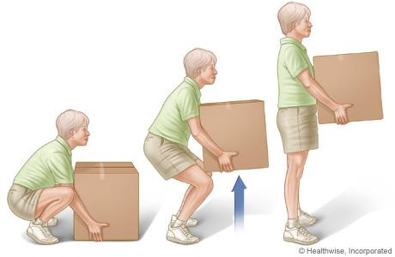

*Basic Lift (Diagonal Lift)*

**Power Lift:** Use the power lift for objects too large for you to straddle. This lift is very similar to the basic lift. In the power lift, the object shifts your center of gravity forward, and you must push your buttocks out to compensate.

1. Put one foot in front of the other using a wide stance.
2. Keep your back straight, push your buttocks out and use your legs and hips to lower yourself down to the object.
3. Move the load as close to you as possible.
4. Grasp the object firmly with both hands.
5. Prepare for the lift and look forward.
6. Lift upwards following your head and shoulders. Hold the load close to your body.

Lift by extending your legs with your back straight, your buttocks out (exaggerate this position), and breathe out as you lift. 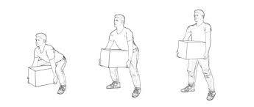

*Power Lift*

**Tripod Lift**: Use the tripod lift for objects with uneven weight distribution (example: sacks of food). Recommended for people with decreased arm strength and not recommended for people with bad knees.

1. Put one foot next to the object. Keep your back straight, push your buttocks out and slowly lower yourself down onto one knee. For support as you lower yourself down, put one hand on a stool or on your thigh for support.
2. Position the object close to the knee on the ground.
3. Grasp the object firmly with both hands.
4. Slide the object from the knee on the ground to mid-thigh. Keep your head forward, your back straight, your buttocks out, and lift the object onto the opposite thigh.
5. Put both of your forearms under the object, with your palms facing upward, and hug the object to your stomach and chest.
6. Prepare for the lift and look forward.
7. Lift upwards following your head and shoulders. Hold the load close to your body. Lift by extending your legs with your back straight, your buttocks out, and breathe out as you lift.

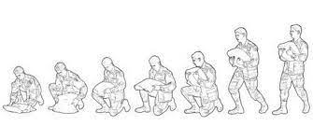

*Tripod Lift*

**Partial Squat Lift**: Use the partial squat lift for small light objects with handles close to knee height.

1. Stand with the object close to your side.
2. Place your feet shoulder width apart, with one foot slightly ahead of the other (karate stance).
3. Place one hand on a fixed surface, such as a table or stool, or on your thigh.
4. Keep your back straight, push your buttocks out and slowly lower yourself down to reach the object’s handles.
5. Prepare for the lift, grasp the object and look forward.
6. For support as you lift, push down on the fixed surface or on your thigh.
7. Lift upwards following your head and shoulders. Lift by extending your legs with your back straight, your buttocks out, and breathe out as you lift.

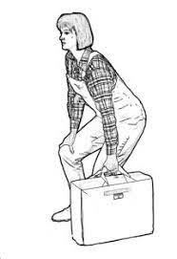

*Partial Squat Lift*

**Golfers’ Lift**: Use the golfers’ lift for small light objects in deep bins and to pick small objects off of the floor. Recommended for people with knee problems or decreased leg strength.

1. Place your hand near the edge of a fixed surface, such as the edge of a table or bin.This hand will support your upper body during the lift.
2. Keep your back straight and raise one leg straight out behind you as you lean down to pick up the object. The weight of your leg will counterbalance the weight of your upper body.
3. Grasp the object firmly.
4. Prepare for the lift and look forward. Keep your leg raised as you initiate the lift.
5. To lift, push down on the fixed surface as you lower your leg. Keep your back straight and breathe out as you lift.

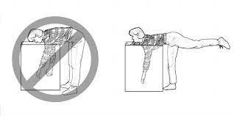

*Golfers’ Lift*

**Pivot Technique**: When you must lift an object and then turn to carry it away, it is common to twist the body. Twisting while lifting can cause serious damage to the tissues of the back. Use the pivot technique to avoid twisting while lifting.

1. Lift the load using any of the previous techniques.
2. Hold the load very close to your body at waist level.
3. Turn the leading foot 90 degrees toward the direction you want to turn.
4. Bring the lagging foot next to the leading foot. **Do not twist your body!**

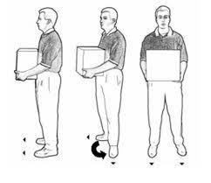

*Pivot Technique*

**Overhead Lift**: Use the overhead lift to place objects on an overhead shelf. This lift begins with the object in your hands. Be careful! Overhead lifts put you at increased risk for muscle strain. It can be difficult to maintain balance during the lift. Only use this lift when absolutely necessary.

1. Hold the object very close to your body.
2. Keep feet shoulder width apart, one foot slightly ahead of the other.
3. Prepare for the lift and look forward.
4. Raise the object to shelf height using the arm and shoulder muscles. Keep the object close to your body and breathe out as you lift.
5. As you reach the shelf, slowly shift your weight from your back foot to your forward foot. Keep your back straight.
6. When the load reaches the edge of the shelf, push the object onto the shelf.

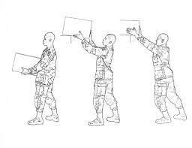

*Overhead Lift*

**Essential Do’s for Proper Lifting:**

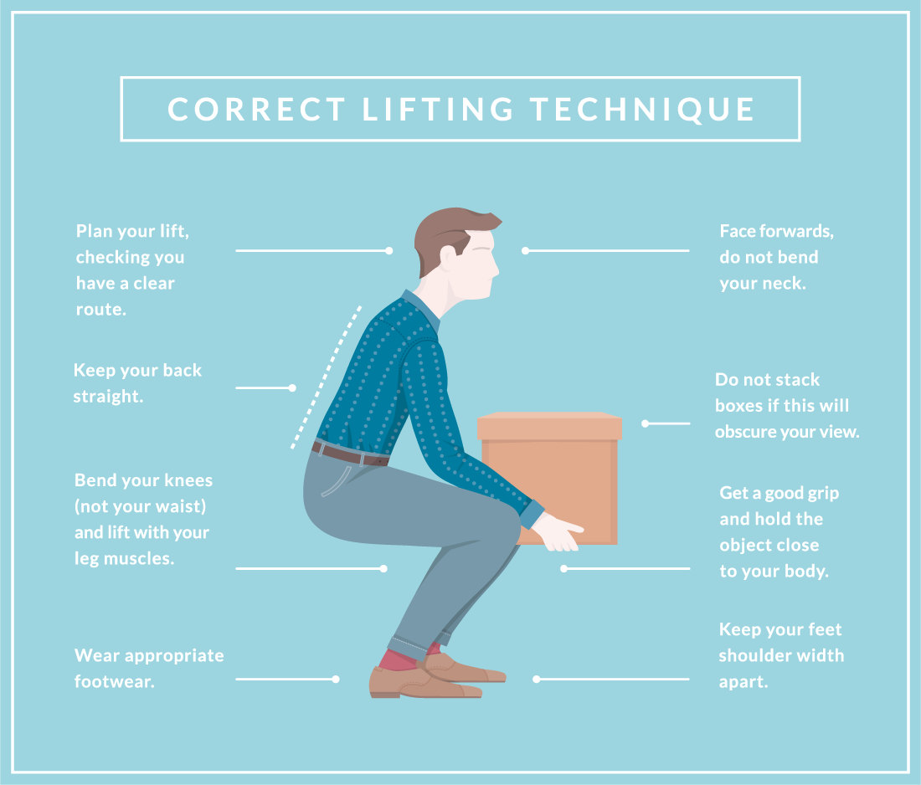

A few essential don'ts to keep in mind for good lifting ergonomics:

* Never twist your torso while lifting. Stay "nose between your toes."
* Never lift a heavy item above shoulder level.
* Never carry a load that obstructs your vision.
* Never hold your breath while lifting, moving, and setting the load down.